pH – Limiting Factors of Aquatic Ecosystems
INTRODUCTION
Table 1: Effects of pH Levels on Aquatic Life
pH | Effect
3.0–3.5 | Unlikely that fish can survive for more than a few hours in this range, although some plants and invertebrates can be found at pH levels this low.
3.5–4.0 | Known to be lethal to salmonids.
4.0–4.5 | All fish, most frogs, insects absent.
4.5–5.0 | Mayfly and many other insects absent. Most fish eggs will not hatch.
5.0–5.5 | Bottom-dwelling bacteria (decomposers) begin to die. Leaf litter and detritus begin to accumulate, locking up essential nutrients and interrupting chemical cycling. Plankton begin to disappear. Snails and clams absent. Mats of fungi begin to replace bacteria in the substrate.
 | Metals (aluminum, lead) normally trapped in sediments are released into the acidified water in forms toxic to aquatic life.
6.0–6.5 | Freshwater shrimp absent. Unlikely to be directly harmful to fish unless free carbon dioxide is high (in excess of 100 mg/L)
6.5–8.2 | Optimal for most organisms.
8.2–9.0 | Unlikely to be directly harmful to fish, but indirect effects occur at this level due to chemical changes in the water.
9.0–10.5 | Likely to be harmful to salmonids and perch if present for long periods.
10.5–11.0 | Rapidly lethal to salmonids. Prolonged exposure is lethal to carp, perch.
11.0–11.5 | Rapidly lethal to all species of fish.
Water contains both hydrogen ions, H⁺, and hydroxide ions, OH–. The relative concentrations of these two ions determine the pH value. Water with a pH of 7 has equal concentrations of these two ions and is considered to be a neutral solution. If a solution is acidic, the concentration of H⁺ ions exceeds that of the OH– ions. In a basic solution, the concentration of OH– ions exceeds that of the H⁺ ions. On a pH scale of 0 to 14, a value of 0 is the most acidic, and 14 the most basic. A change from pH 7 to pH 8 in a lake or stream represents a ten-fold increase in the OH– ion concentration.
Rainfall generally has a pH value between 5 and 6.5. It is acidic because of dissolved carbon dioxide and air pollutants, such as sulfur dioxide or nitrogen oxides. If the rainwater flows over soil containing hard-water minerals, its pH usually increases. Bicarbonate ions, HCO₃–, resulting from limestone deposits react with the water to produce OH– ions, according to the equation:
HCO₃– + H₂O → H₂CO₃ + OH–
As a result, streams and lakes are often basic, with pH values between 7 and 8, sometimes as high as 8.5.
The measure of the pH of a body of water is very important as an indication of water quality, because of the sensitivity of aquatic organisms to the pH of their environment. Small changes in pH can endanger many kinds of plants and animals; for example, trout and various kinds of nymphs can only survive in waters between pH 7 and pH 9. If the pH of the waters in which they live is outside of that range, they may not survive or reproduce.
Changes in pH can also be caused by algal blooms (more basic), industrial processes resulting in a release of bases or acids (raising or lowering pH), or the oxidation of sulfide-containing sediments (more acidic).
Factors that Affect pH Levels
- Acidic rainfall
- Algal blooms
- ll blooms in body of water
- Level of hard-water minerals
- Releases from industrial processes
- Carbonic acid from respiration or
decomposition
- Oxidation of sulfides in sediments
To gain a full understanding of the relationship between pH and water quality, you need to make measurements of the pH of a stream, as described in this test, and also determine the stream’s alkalinity, as described in Test 11 in this manual. Alkalinity is a measurement of the capacity or ability of the body of water to neutralize acids in the water. Acidic rainfall may have very little effect on the pH of a stream or lake if the region is rich in minerals that result in high alkalinity values. Higher concentrations of carbonate, bicarbonate, and hydroxide ions from limestone can provide a natural buffering capacity, capable of neutralizing many of the H⁺ ions from the acid. Other regions may have low concentrations of alkalinity ions to reduce the effects of acids in the rainfall. In the Northeastern United States and Eastern Canada, fish populations in some lakes have been significantly lowered due to the acidity of the water caused by acidic rainfall. If the water is very acidic, heavy metals may be released into the water and can accumulate on the gills of fish or cause deformities that reduce the likelihood of survival. In some cases, older fish will continue to live, but will be unable to reproduce because of the sensitivity of the reproductive portion of the growth cycle.
Expected Levels
The pH value of streams and lakes is usually between pH 7 and 8. Levels between 6.5 and 8.5 pH are acceptable for most drinking water standards. Areas with higher levels of water hardness (high concentrations of Mg²⁺, Ca²⁺, and HCO₃– ) often have water with higher pH values (between 7.5 and 8.5).
Summary of Methods
The preferred method is to use a pH Sensor to make on-site measurements of the pH level in a stream or lake.
As an alternative, the water sample is taken from the stream or lake and stored in an ice chest or refrigerator. After returning to the lab, samples are allowed to return to room temperature, and the pH is measured using a pH Sensor.

pH Measurement
Collection of Samples
1. We will be conducting the test back in the lab. Please use the 1000mL Ziploc container to collect a 250mL water sample. Make sure to record your container number on your lab sheet.
2. It is important to obtain the water sample from below the surface of the water while being safe.
3. Please secure the lid and do not shake the container as you transport it back to the lab.
4. Complete the field observations on page 4 and use the camera to take some pictures of the test site surroundings.
5. Follow the teacher via the sidewalk to and back from the lake. Travel in a fashion that represents us all well.
Testing Procedure (back in the lab)
1. Connect the pH Sensor to LabQuest and choose New from the File menu.
2. Set up the data-collection mode.
- On the Meter screen, tap Mode. Change the data-collection mode to Selected Events.
- Call the event Black Otter Lake
- Scroll to the bottom, select average data over 10 seconds and select OK.

3. Collect pH data.
- Select graph mode.
- Start data collection by pressing the green play button
- Remove the pH Sensor from the storage bottle. Rinse the tip of the sensor thoroughly with distilled water. (today please use water from the sink)
- Place the tip of the sensor sample water of from the stream/pond/lake. Submerge the sensor tip in the container to a depth of 3–4 cm. Swirl the sensor in the water for 3 seconds.
- Stop swirling and Tap Keep to collect the first data pair. Important: Leave the probe tip submerged while data is being collected for 10 seconds.
- Remove the sensor and rinse the tip of the sensor thoroughly with distilled water.
- Repeat steps d and e.
- When finished please press the red stop button(square)
- Tap Table to view the data. Record the averaged pH values for readings 1 and 2.
- Rinse the sensor with distilled water and return it to the storage bottle when you have finished collecting your data.
DATA & CALCULATIONS
pH Measurement
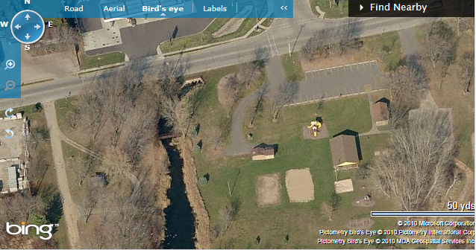
Name: ____________________________________
Camera #: _________________________________
Container #(water sample)_____________________
Name of stream or lake:
Time of day:

Column | LabQuest # _________
Location | pH  (pH units)
Site 1 – boat landing
N44º20.073’
W088º37.864’
Site 2 – end of gravel
Road
N44º20.010’
W088º37.873’
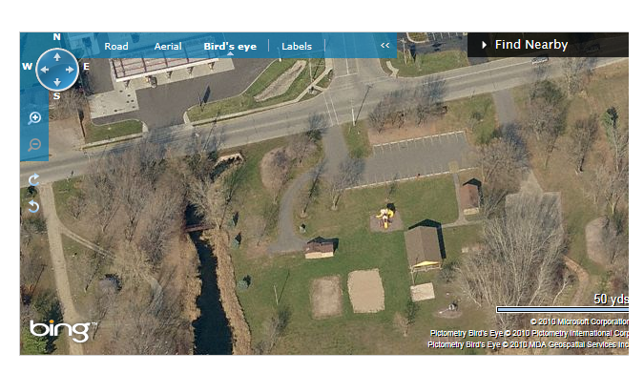
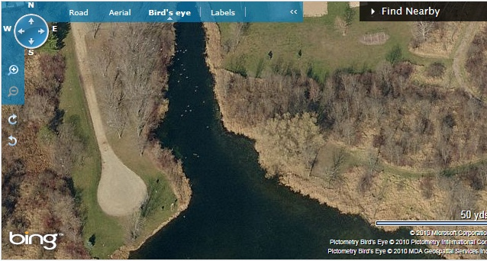

Field Observations (e.g., weather, geography, vegetation along shoreline)

If interested visit www.blackotterlake.com for photos slideshows of the lake restoration project.
Test Completed: ________________ Date: ______

The pH value is calculated as the negative log of the hydrogen ion concentration: pH = –log [H⁺].

